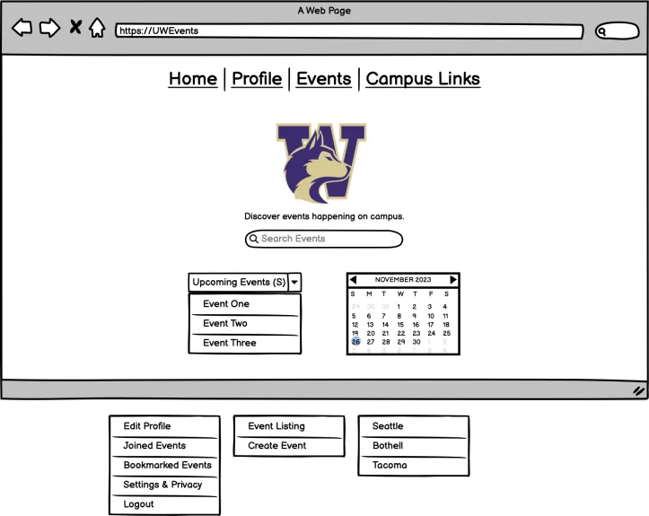

UW Events Draft Design

Project Group Members: Alon Levy, Jasmine Losovsky, Brittney Oeur, Vincent Tran, Jocelyn Velazquez

INFO 200 | Section AB | TA: Amy Oguejiofor

Table of Contents

**Solutions Considered 2**

Solution 1 2

Solution 2 3

Solution 3 3

Solution 4 3

**Selected Solution 4**

**Description of Your Solution 4**

Product Features 5

Primary Features 5

Secondary Features 6

SiteMap 6

Low Fidelity Wireframes 7

Brainstorming Stage 7

Final Low-Fidelity Wireframes 12

**Usage Scenarios 13**

Usage Scenario 1 13

Usage Scenario 2 13

User Journey Map 14

**Bibliography 15**

**Appendix 15**

# 

# Solutions Considered

## Solution 1

## The idea of developing a mobile application dedicated to UW event organization is the first solution devised. This will include features that are suggested by students. These include lots of filters and a user-based system where students can log in and include information about themselves. The primary advantage of an application is its convenience. It will offer users an easily accessible, simple, and responsive platform for event information. A drawback is its limited accessibility to computers, excluding students who prefer using computers or who do not have a smartphone. Another limitation is that all clubs and organizations would have to download the application.

## Solution 2

## A network of social media accounts created to organize and display UW events to students is the second considered solution. This idea is heavily based on suggestions from an interview with a primary stakeholder. The solution includes a main social media account showing big events or events not relating to any topic. Then it will have links to accounts dedicated to posting event information for specific majors or interests. The primary advantage of social media accounts is that the solution will reach students on its own very quickly because once a few students follow an account it will show up on their friends’ feeds. However, accounts such as these will experience and distribute clutter. Students will have to look through several accounts and scroll through several posts to find what they are looking for. Also, each student’s feed will be filled with posts about events they may not care about. Furthermore, relying solely on social media excludes students who are not active on these platforms.

## Solution 3

A website is another solution that serves this problem. The website will have a homepage, an event page for each individual event, and a filtering tool. A user will log in with their UW ID and will be able to view a calendar, a filtering tool for specific event searching, and events they have attended recently or want to attend, by their choice. The advantage is that it will let anyone who is part of UW see all the events happening in one place, and with a couple of clicks, filter them to tailor events toward the users’ interests. They can also save events that interest them and always refer at a later time. The disadvantages include limited access. The system is only built for people with a UW ID and there are populations lacking the criteria that are still interested in events UW offers.

## Solution 4

The final solution is a booth that holds flyers for all the events. It will be divided into different types of events, various departments, etc. All the different events will be displayed on eye-catching paper flyers. The advantage is that it allows the event organizers to express their creativity in marketing events to bring more participants. A disadvantage is the space all the event flyers will occupy. Since there are many events going on, there might not be a place big enough to hold all the flyers. It is also a big waste of paper because there are so many events. Another disadvantage is the time and effort placed into creating fun posters. Event organizers may not prioritize aesthetic physical promotions, and that might draw fewer people to attend their events.

**Table 1:**

|  | Solution 1 | Solution 2 | Solution 3 | Solution 4 |
| --- | --- | --- | --- | --- |
| Description | Mobile Application | Social Media Account | Website | Flyers/Posters |
| Advantages | Convenience: Easy to use, simple, responsive | Easy to advertise. Easy to link to club social media accounts. | Able to have access to many events in one go anywhere and anytime. | This can help make the event seem more appealing, thus attracting more people. |
| Disadvantages | Difficult to access from a computer. All clubs need to download it. Need access to a mobile device. | Too cluttered. No specific filters, so the media is not narrowed down enough. | Must have access to the internet. | Can take up a lot of space that may already be occupied and it produces a lot of paper. |

# Selected Solution

The selected solution is creating a website system for the events. A website is accessible to most people in the UW database (students, professors, workers, etc.). Through a computer, tablet, or phone they can easily view all the current events and filter them to their liking for a specific search. It makes finding events a lot easier since many events are spread on different websites and social media platforms. With this solution students save the events they want to attend and can RSVP to the ones they will be attending, all in one place. It has advantages over the rest since people can access it from all electronic devices, whereas a mobile app is limited to mobile phones. Flyers require people to physically be on campus and visit a specific place for event information. Social media is limited only to students active on social media platforms. The website is operated on technology and software, removing the use of physical materials. The website also provides tools that are missing in flyers such as filtering and RSVPs. The reasons above are advantageous over the other solutions, hence the decision for the best solution. With one click, the program is an effective solution for accessibility and event searching.

# Description of Your Solution

In the final solution, the simple interface is tailored for the target population of students, faculty/staff, and event organizers. The system deploys an interface that allows users to operate it intuitively. This would mean featuring the search bar on the landing page so that users do not have to go looking around for it. By doing this, users can quickly identify where the filter button is (to its right) and use it to assist them in displaying relevant results. The solution aims to include a sort of “catch-all” regarding event information such as location, RSVP, and descriptions, so it was important this all be displayed on a single, scrollable page. Because the main goal of this redesign was to eliminate any confusion, it was essential that all features be easy to find. For example, the homepage only features a few recommendations, a calendar, and a search bar, but the user could easily guide themselves to accessing more detailed information. Once searching and filtering, they can find a list of events and click on each for specific details. For returning users, they can easily access their saved and joined events. Overall, the steps that a user takes to be as logical as possible: search, describe, find, access, and save.

## Product Features

### **Primary Features**

**Navigation bar:**

* **Home tab:** Provides a quick way to return to the main page, ensuring easy navigation.
* **Profile tab (drop-down menu):** Enables users to access and manage their personal information, enhancing customization and control over their experience.
* **Events (drop-down menu):** Offers direct access to various event categories or types, making event exploration more convenient.
* **Campus Links (drop-down menu):** Provides access to different campus-related resources or information, aiding users in finding campus-specific details easily.

**Landing-Page:**

* **Search bar:** Allows users to find specific events or information quickly, enhancing usability.
* **Mini-calendar:** Offers a visual representation of dates, enabling users to quickly navigate to specific event dates.
* **Upcoming Event Listing:** Provides immediate visibility into forthcoming events, making it easier for users to plan their attendance or participation.

**Event Listing:**

* **Chronological order:** Facilitates users in staying updated with the latest events by showing them in order of occurrence.
* **All-campus events:** Offers a comprehensive view of events across all UW campuses, providing a broader range of choices and opportunities.
* **Filtering System:** Allows users to personalize their event search based on preferences, optimizing their experience by displaying events that match their criteria. Filters include checklists and drop-down menus.

**Creating Event:**

* Users are able to create their own events by providing the date, time, event name, description, location, graphics, and filter tags.

### **Secondary Features**

**Filtering System:**

* **Filter events by major type:** Helps users focus on events relevant to their academic or professional interests, streamlining their search and maximizing the relevance of discovered events.
* **Filter events by different types:** Allows users to narrow down their preferences, making it easier to find specific events like career-focused gatherings, specialized workshops, or unique occasions like Makers Fairs, ensuring they find events aligned with their goals or interests.
* **Filter events by online or in-person status:** Provides clarity on event accessibility, saving time by filtering out events that might not suit the user's preference for physical attendance or online participation.
* **Filter events by perks:** Enables users to find events offering additional benefits like free food or merchandise, enhancing the overall experience and potentially influencing their decision to attend.
* **Filter events by date(s):** Facilitates planning by allowing users to find events based on their availability, ensuring they can participate on preferred days without missing out on key engagements.
* **Filter events by specific campus(es):** Tailors the search to a user's location or preferred venue, ensuring they discover events within their proximity or in areas they frequent, promoting convenience and accessibility.
* **Filter events by theme:** Offers a personalized experience by allowing users to explore events aligned with specific themes of interest, catering to diverse preferences and enhancing engagement with events that resonate with their passions or objectives.

**Individual Event Page:**

* **Save/Join events:** Allows users to efficiently manage their event interests, facilitating easy access to favored events and enabling prompt registration or attendance, ensuring they don’t miss out on important engagements.
* **Embedded maps (Google/Apple):** Enhances user convenience by providing integrated maps for each event, allowing for seamless navigation and a clear understanding of event locations, reducing the hassle of searching for directions separately.
* **Date, time, and location details:** Offers vital information upfront, allowing users to quickly assess event schedules and logistics, aiding in better planning and ensuring they can participate without scheduling conflicts.
* **Graphic poster/flyer:** Enriches the event information by showcasing visual content such as social media posters, banners, or illustrations, providing a more engaging preview and enticing users with visual appeal.
* **Tags (similar to hashtags):** Streamlines the user experience by displaying tags for various filters and chosen preferences (Type, major, in-person/remote, campus, etc.), simplifying navigation and ensuring users are aware of their selected filters, making it easier to refine or adjust their search criteria as needed.

**User Profile:**

* **Customizable icon button:** Enables users to personalize their profile, fostering a sense of individuality and ownership, allowing them to express themselves through a unique icon, enhancing the user experience.
* **Settings and privacy button:** Empowers users with control over their account settings and privacy preferences, ensuring a secure and tailored experience that aligns with their comfort and needs.
* **Organized event lists (Created, Joined, Bookmarked):** Provides users with easy access to their event history, streamlining their ability to track and manage events they've created, joined, or bookmarked, facilitating seamless navigation and enhancing engagement with preferred events.
* **Logout button:** Offers a straightforward way to sign out, ensuring account security and privacy, and providing a hassle-free exit from the platform when needed, contributing to a smooth and secure user experience.

## SiteMap

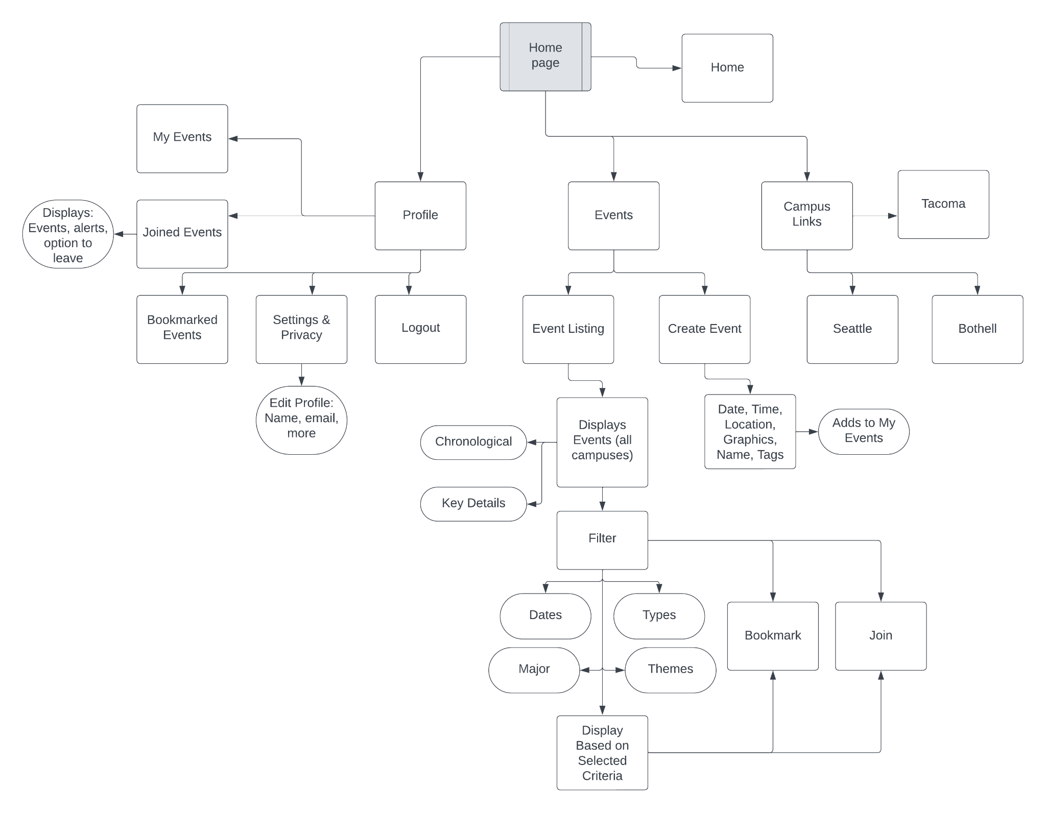

SiteMap displaying the structures and the features of the chosen solution.

## 

## Low Fidelity Wireframes

### Brainstorming Stage

* Sketches:

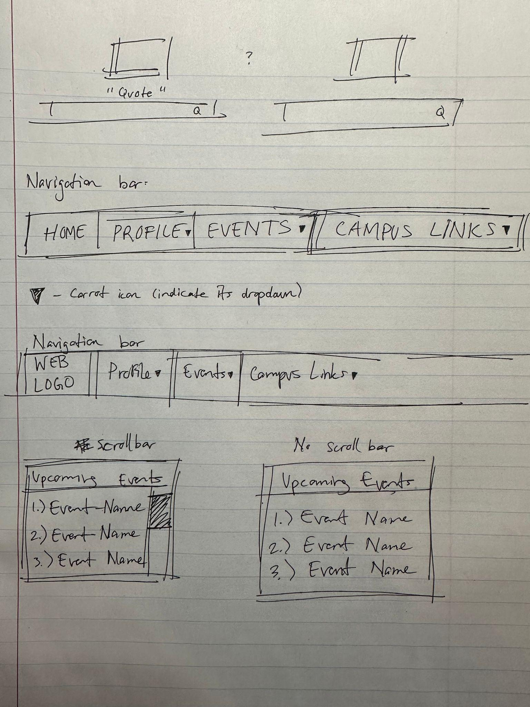

Sketch of the website’s user interface.

**Pages being included (BRAINSTORM, NOT ACTUAL WIREFRAMES):**

* The team plans on primarily using the colors, purple, black, and white (similar to the University of Washington colors).
* This is simply how the team imagines the layout will be.
  + This was quickly made on Canva.
* The color purple will be mainly used to indicate that the button has been clicked on.
* **Homepage/Landing page idea:**

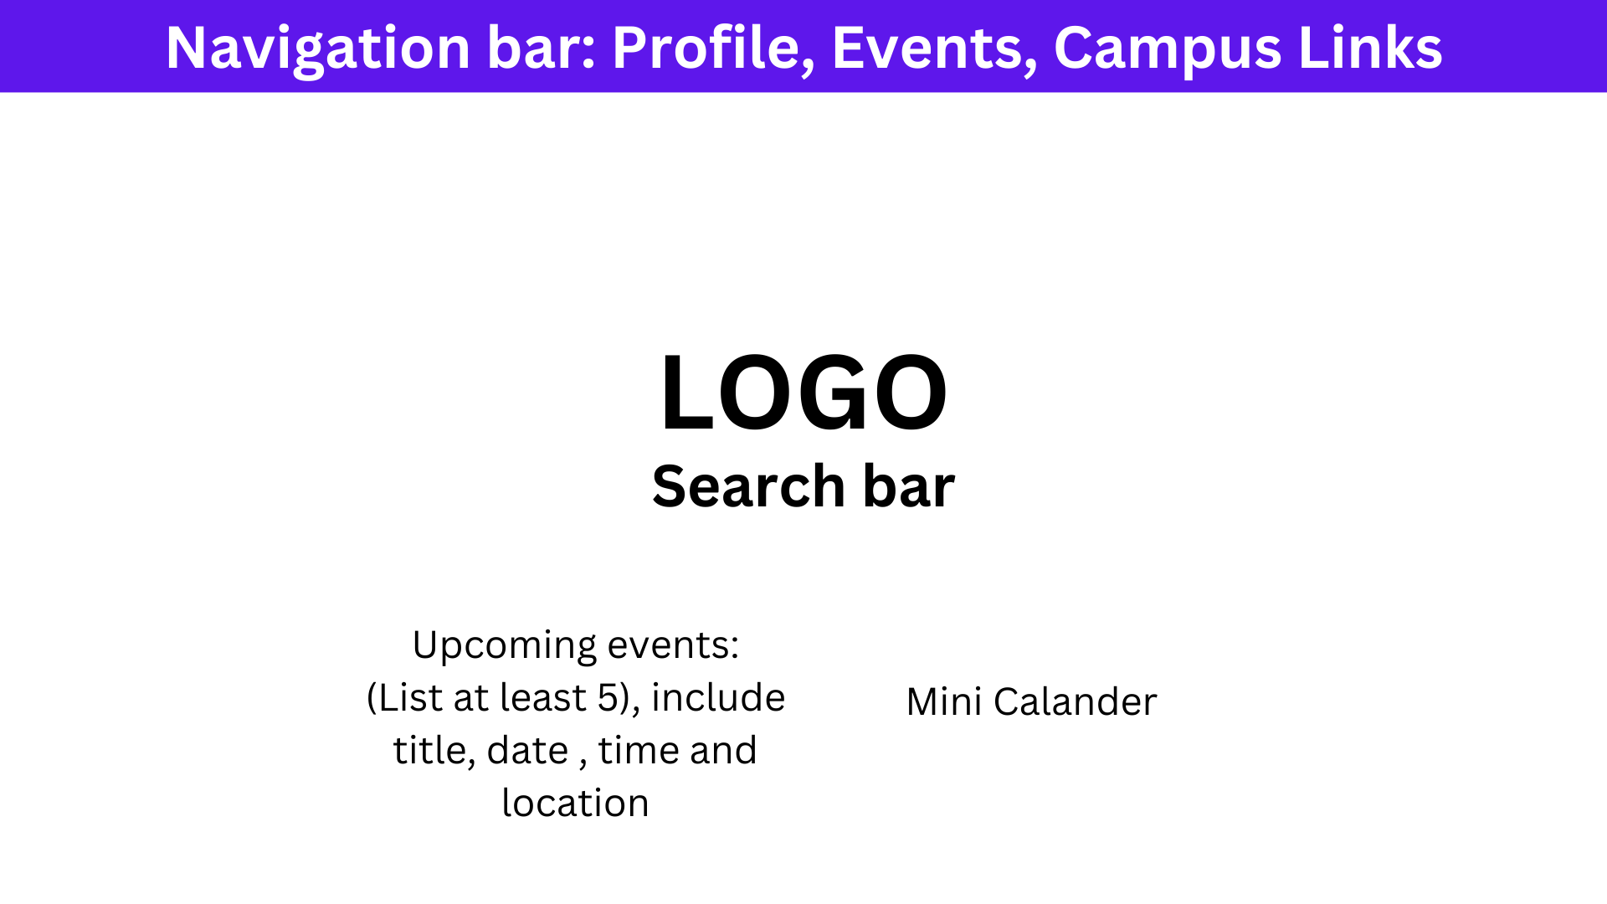

* **Events Listing page idea:**

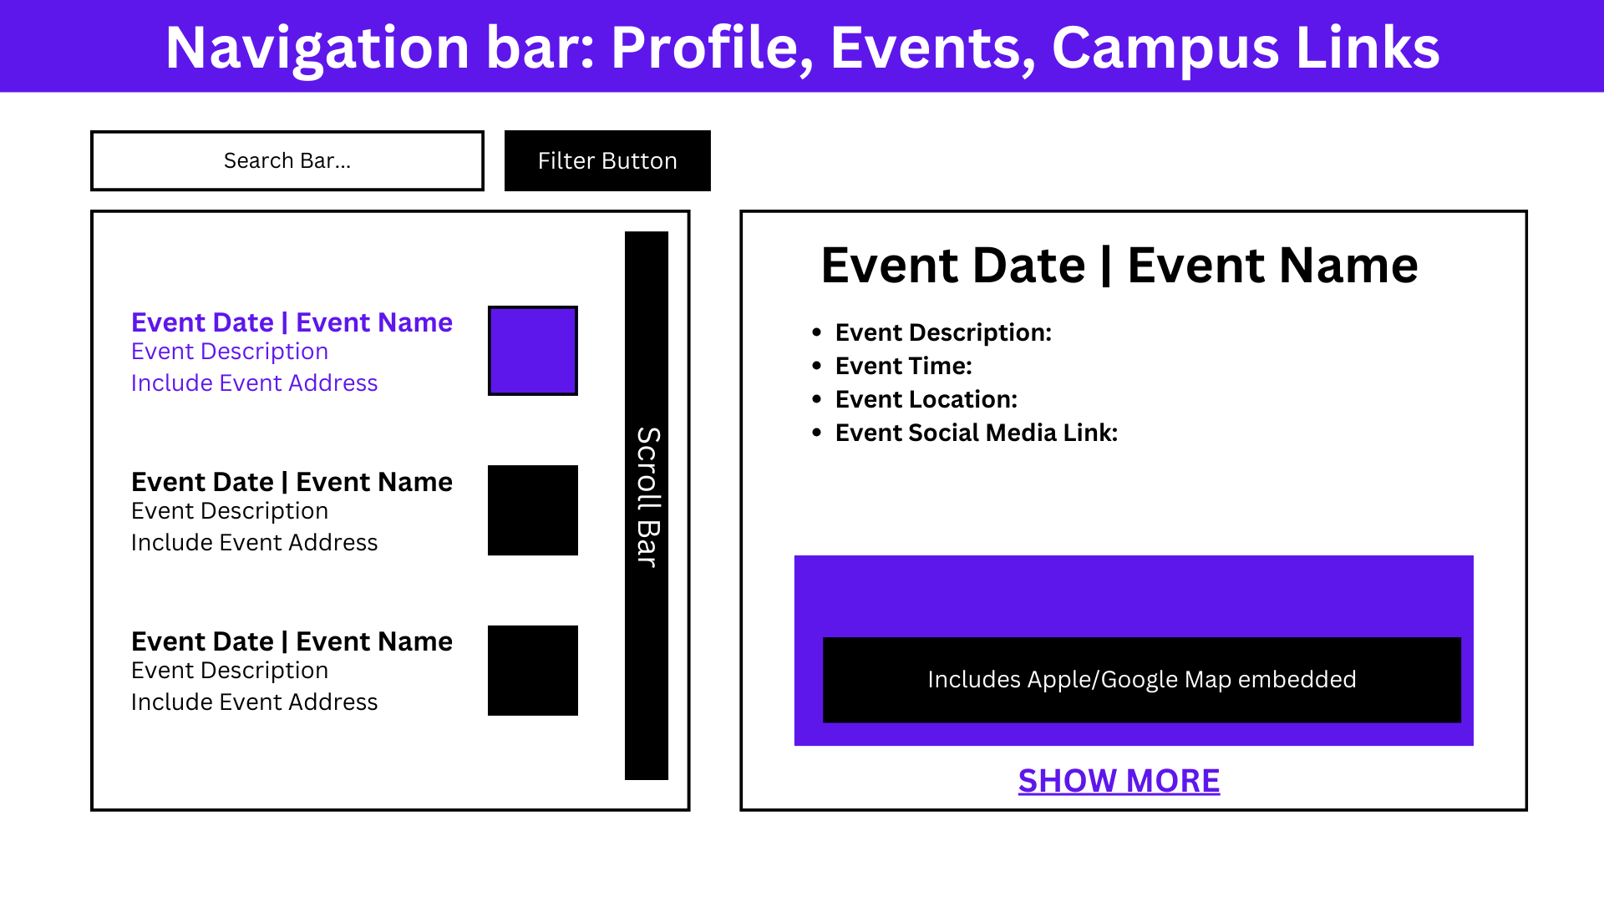

* **Filter option idea:**

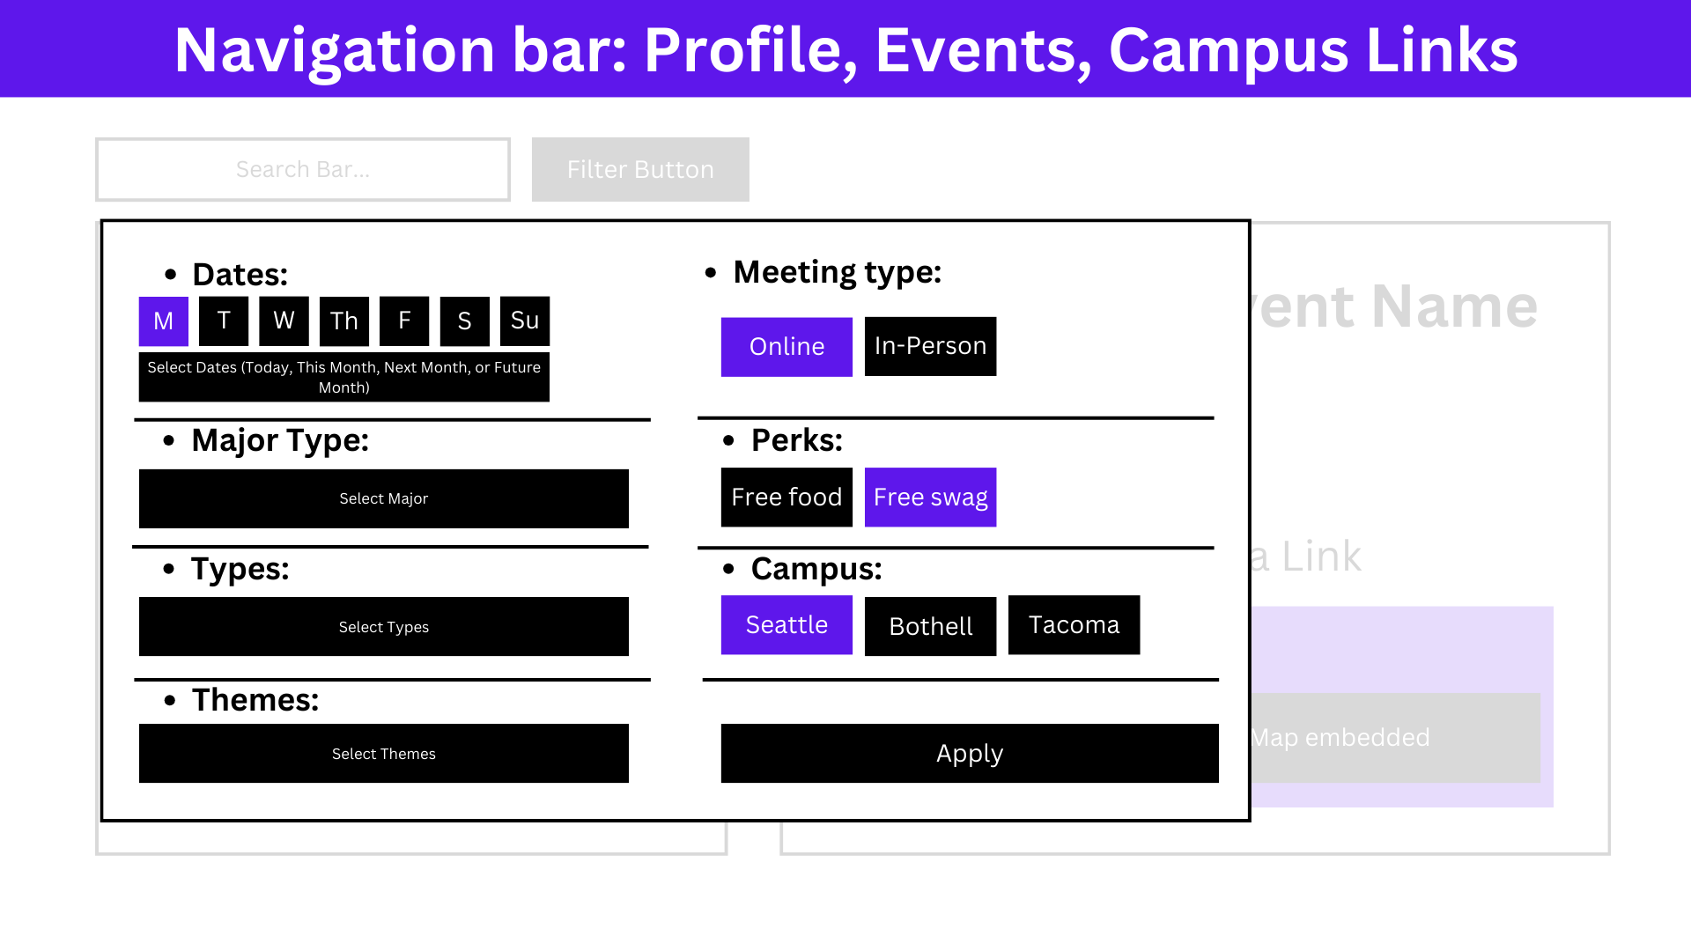

* **Events listing page after filtering idea:**

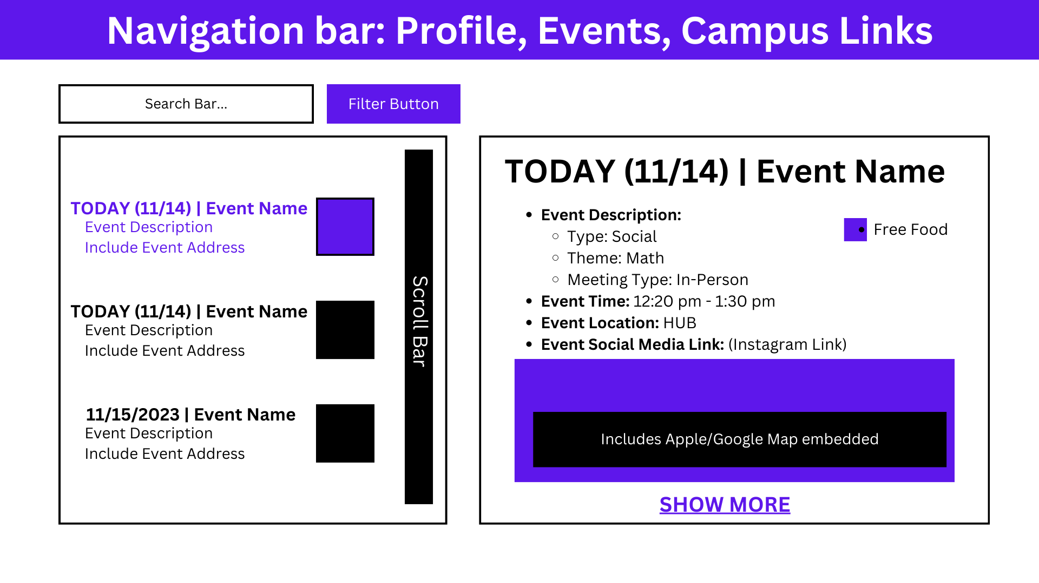

* **Individual event page idea:**

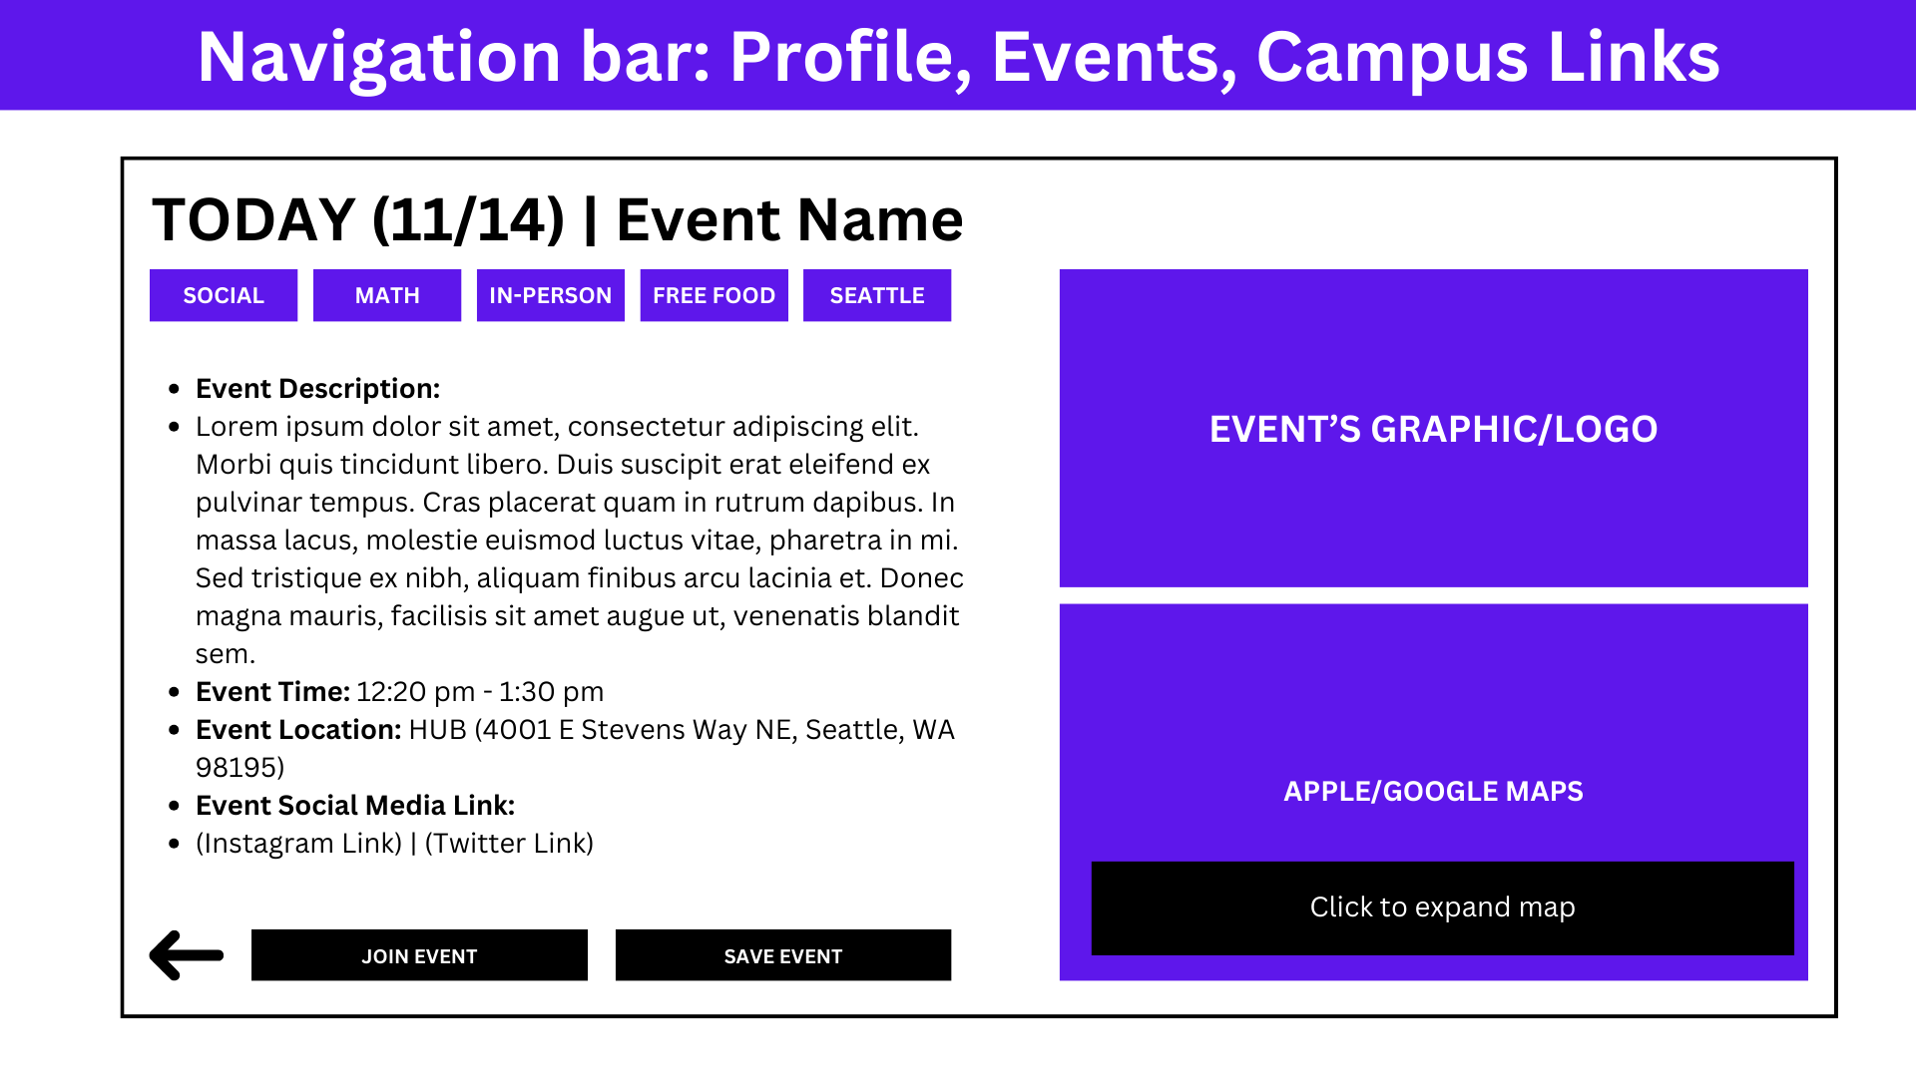

* **User profile page idea:**

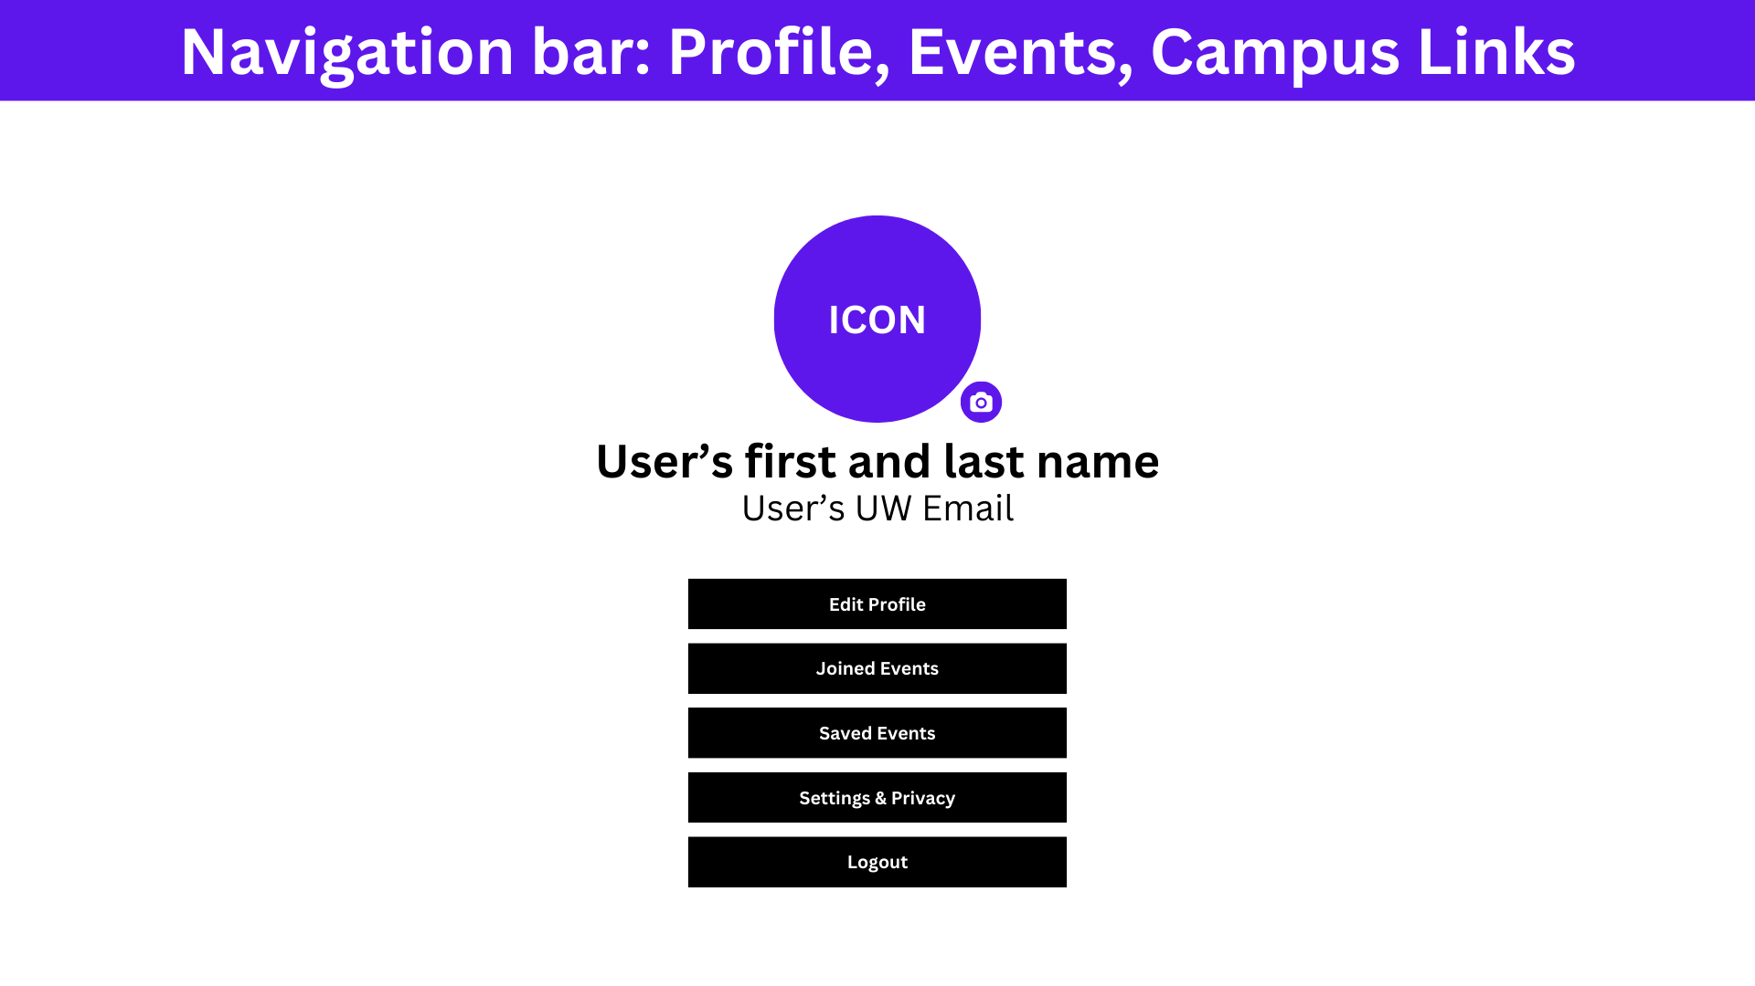

### 

### 

### Final Low-Fidelity Wireframes

**Landing Page (Annotations):** Upon entering the website, users encounter the main page designed akin to Google's layout, featuring a centered search box with the logo above it. This design draws the user's attention to the center of the screen. Below, two boxes are displayed: on the left, based on what UW campus is selected, a list of upcoming events will appear, and on the right, a calendar where the current date is highlighted.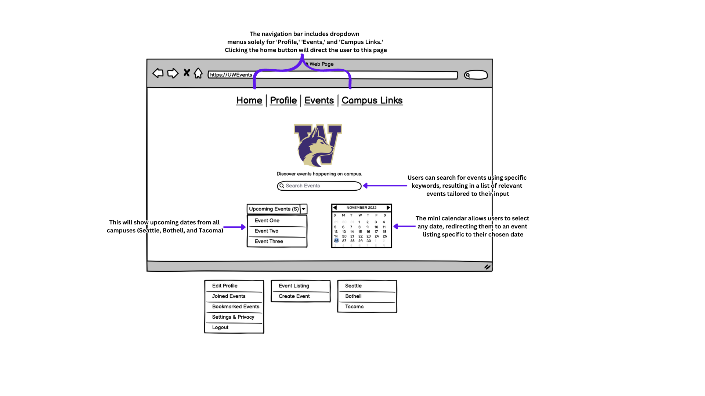

**Example of drop-down menu boxes:  
Left box:** Profile   
**Middlebox:** Events   
**Right box:** Campus Links & Upcoming Events (on the bottom left of the homepage)



**Event Listing (Annotations):** Selecting the ‘Events’ tab redirects users to the event listing page, displaying events from all UW campuses arranged chronologically by dates. On the right side, a small box provides key details about the selected event.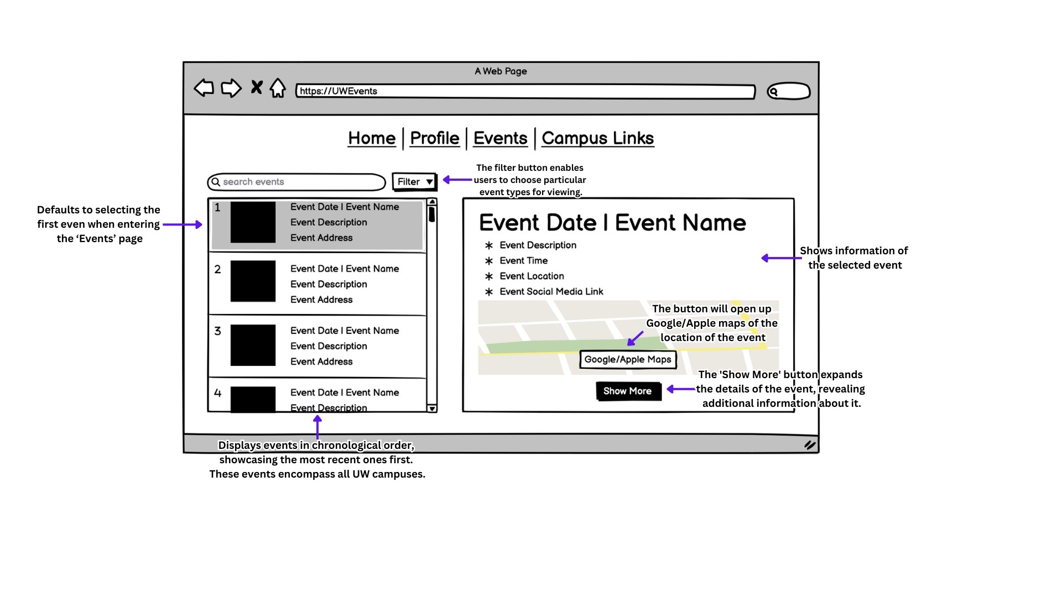

**Filter Option (Annotations):** Clicking the filter button will reveal a menu overlaying the current page, presenting various options for selection. Some options allow multiple selections, while others permit only one choice.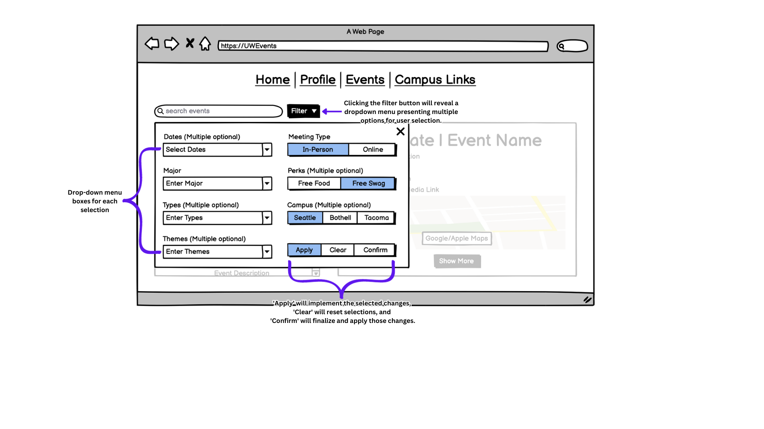

**Example of drop-down menu boxes:**  
**First box:** Dates (Multiple optional)  
**Second box:** Major  
**Third box:** Types (Multiple optional)  
**Fourth box:** Themes (Multiple optional)

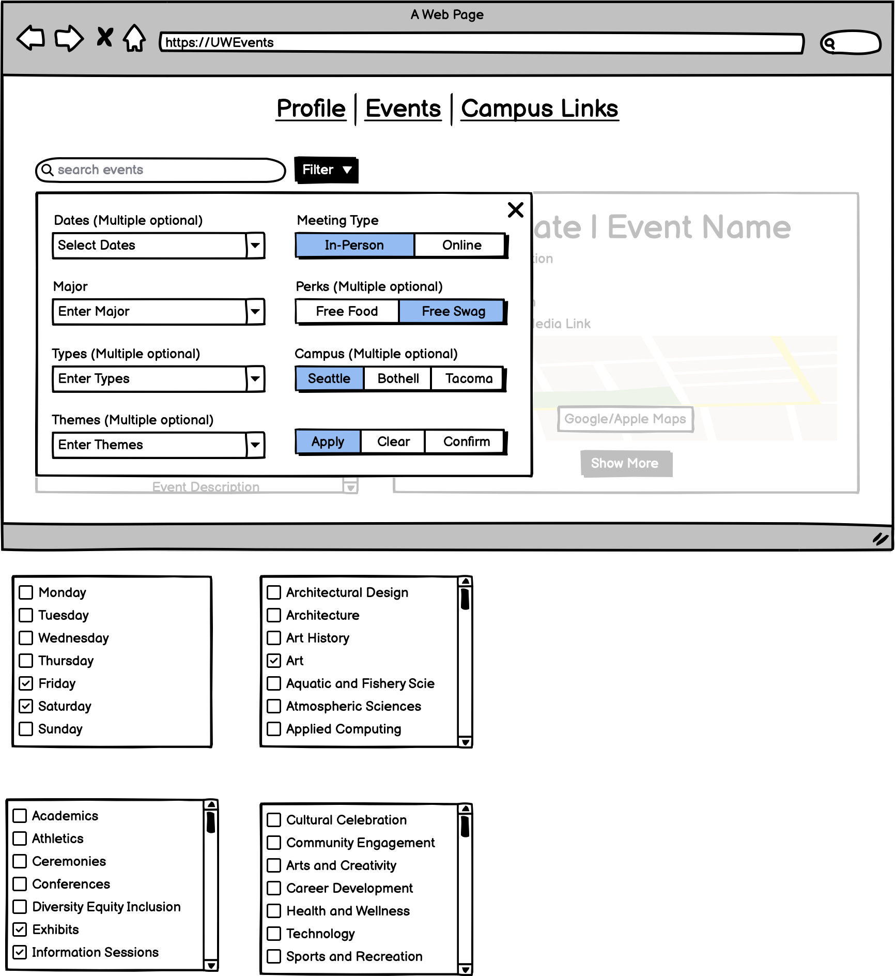 

**Filtered Event Listing (Annotations):** Upon selecting 'confirm,' the filter menu will vanish, leading to a screen refresh displaying specific events tailored to match the selected criteria. This refined list mirrors the event page scan filters, listing events chronologically by date.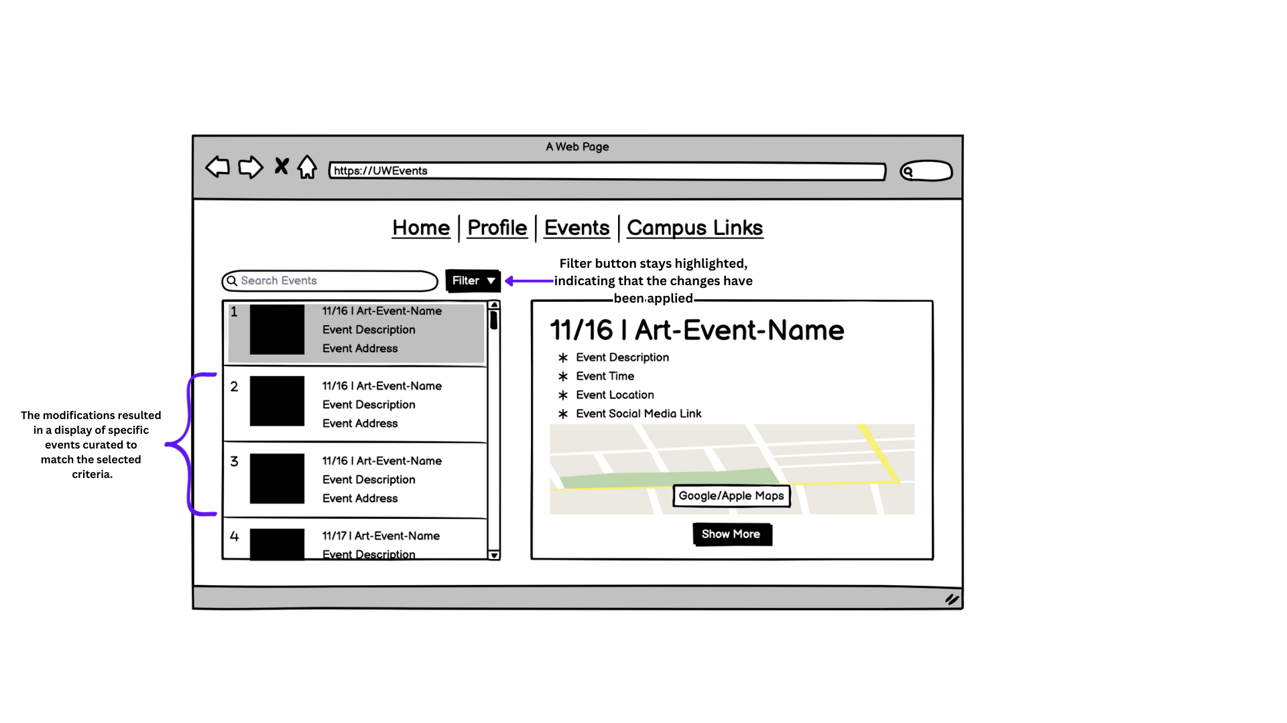

**Filtered Individual Event (Annotations):** When the user clicks the 'show more' button for their chosen event, it expands to reveal the individual event page. Here, more details and information about that event are displayed, and the user can choose to join or bookmark the event from this expanded view.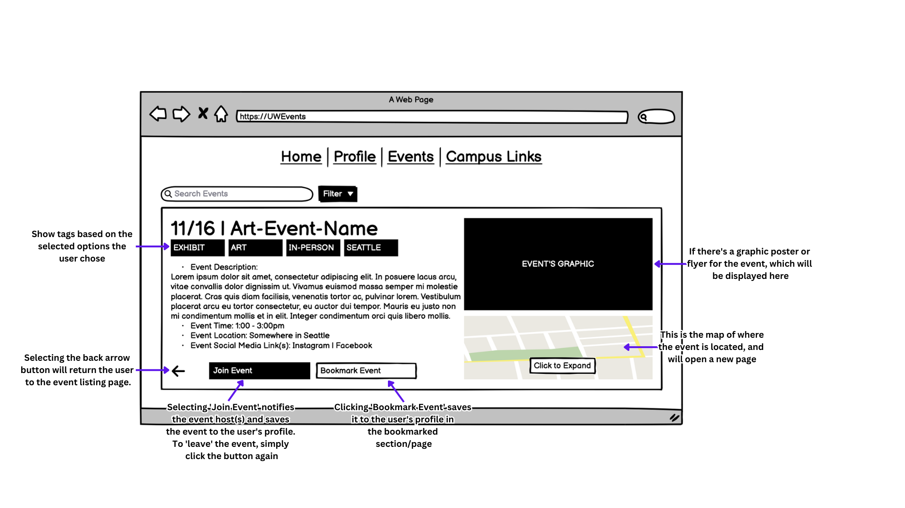

**User’s Profile (Annotation):** After joining the event, the user can navigate to their profile by selecting the ‘Profile’ tab from the navigation bar. On their profile page, their icon will be centered with their first and last name along with their UW email below it. Below these details, there will be five buttons that when clicked, will redirect them to specific pages on the current site.

* **My Events:** Displays events that the user has created.
* **Joined Events:** Lists events that the user has joined.
* **Bookmarked Events:** Shows events that the user has bookmarked.
* **Settings & Privacy:** Users are able to edit their profile details such as their name, UW email, and more.
* **Logout:** Logs the user out of the account.

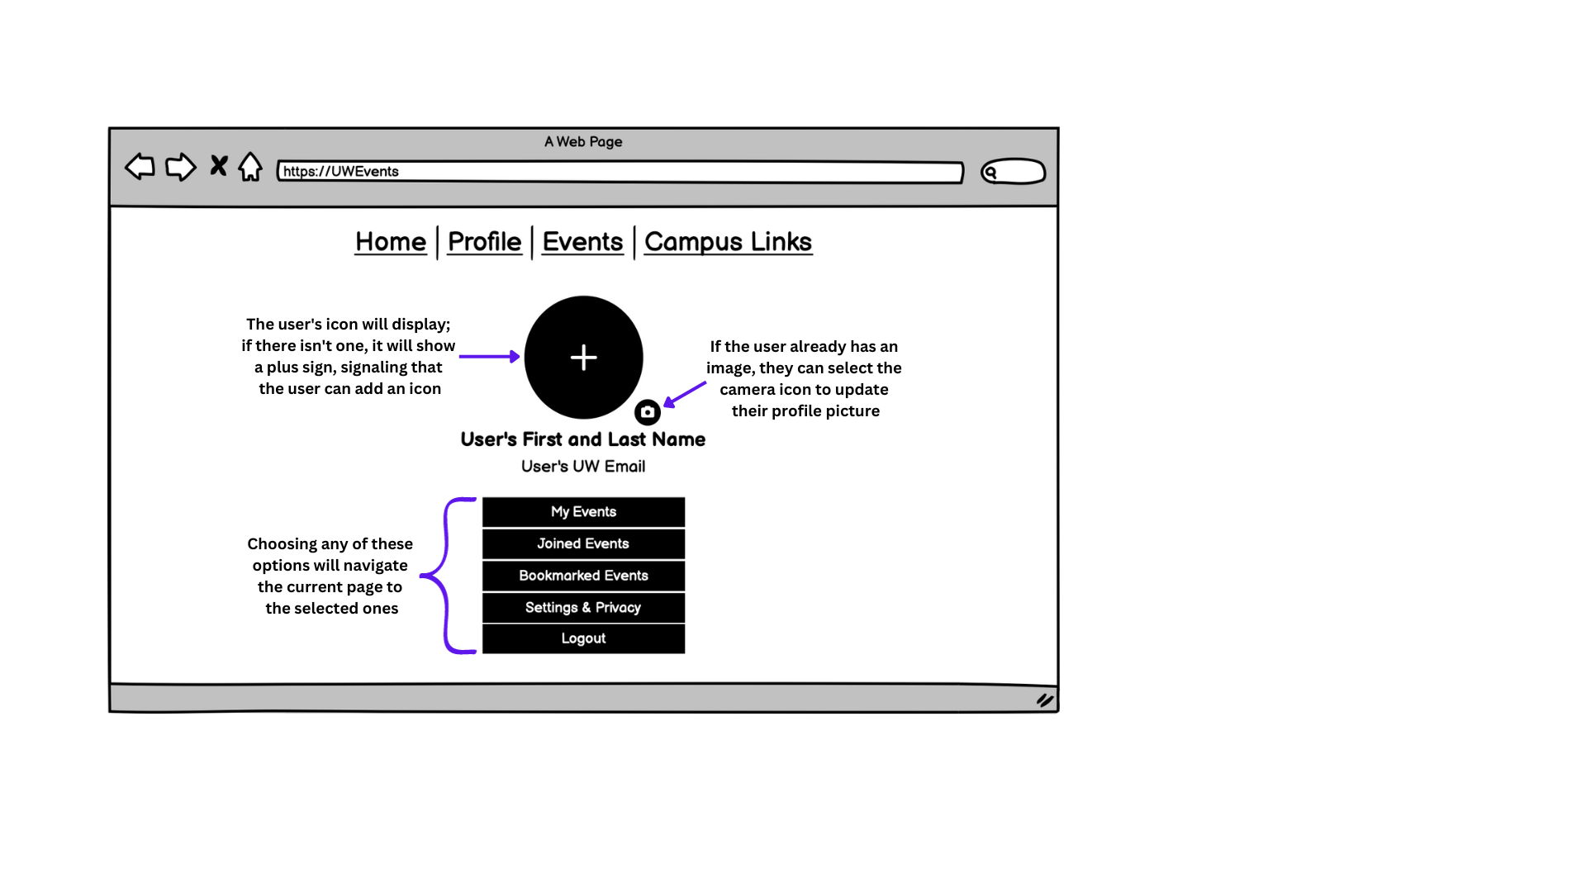

**Joined Events (Annotations):** After clicking the ‘Joined Events’ button, the user is redirected to a page similar to the event listing, showcasing only events they've joined. Additional features include a bell icon, enabling event notifications via text or email (highlighted when activated), and the 'leave event' button, allowing users to ‘leave’ the event and remove it from their ‘joined events’ list.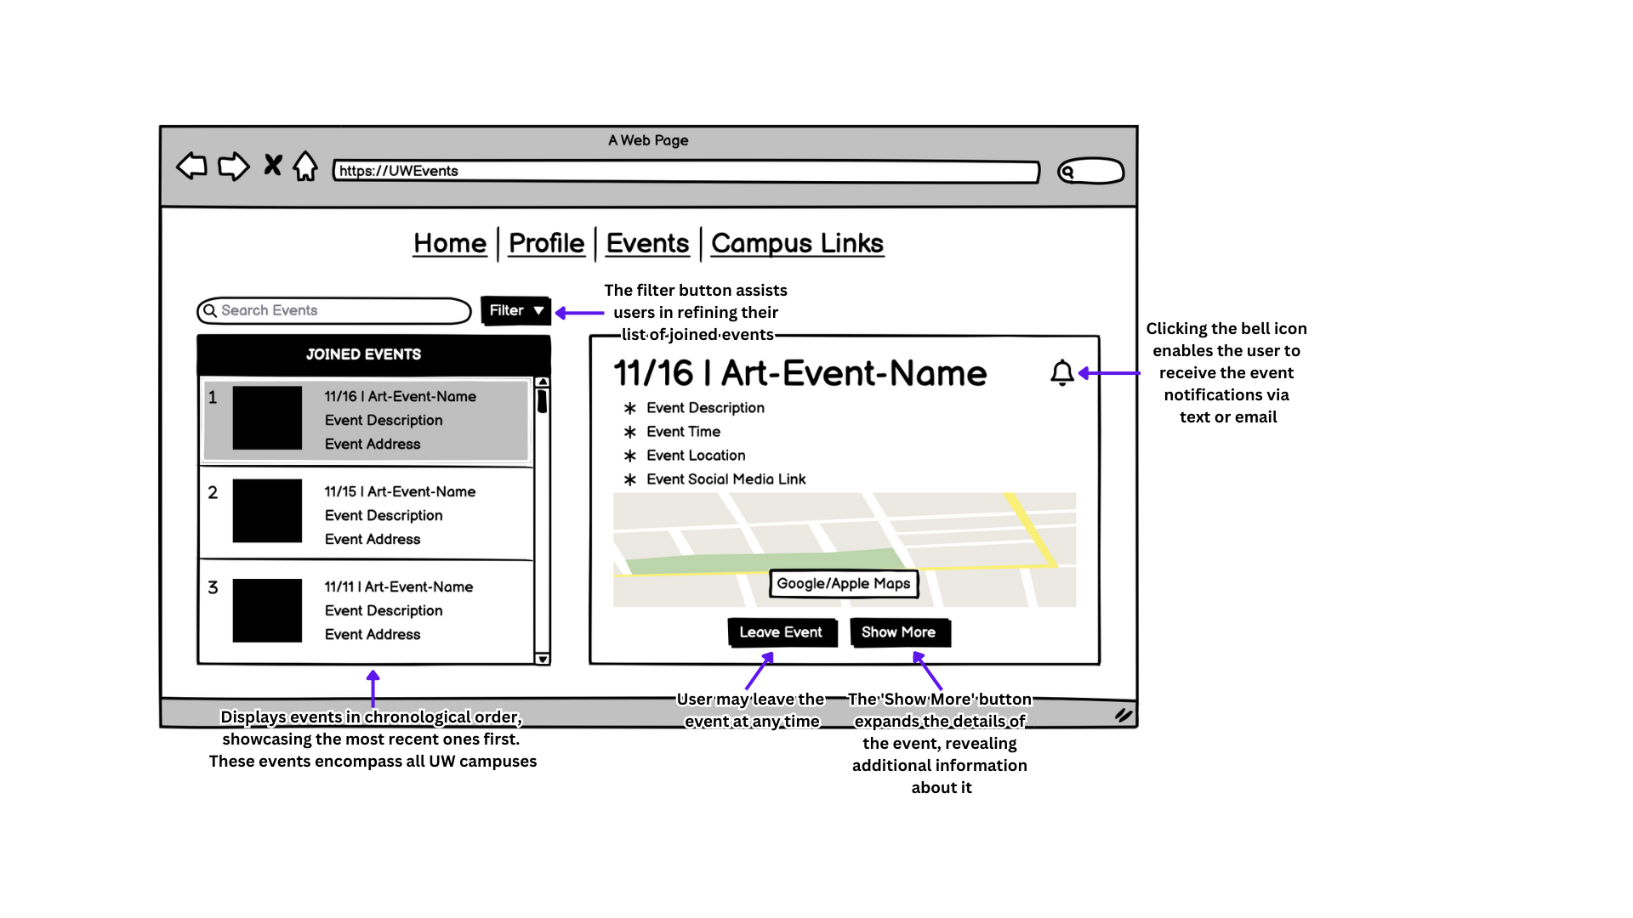

# Usage Scenarios

## Usage Scenario 1: Finding a club based on a hobby

Alexa is a 21-year-old psychology major interested in finding a club to relieve some stress, but can also fit into her busy schedule. So far, she is unsure if she is able to commit to a club with weekly meetings, as her TA job may sometimes have her working an irregular schedule. She decides she wants to find a club based around plants. To do this, Alexa lands on the homepage and types in the word “plant” in the search bar at the top. In doing so, she finds various events with the keyword “plant” highlighted in the event description. However, the top results all conflict with her schedule, so she decides to narrow her search by selecting the filter button and choosing specific days. Now that all the events listed are doable, she saves every event but only clicks “join event” on the ones she finds the most interesting. The site's map features make it easy for Alexa to try out different clubs until she lands on a gardening club that she becomes a frequent attendee of. After a couple of weeks, she used the same website to find the gardening club’s social media and apply for a club leadership position.

## Usage Scenario 2: Promotion of a new club

Anthony is a computer science major and the founding member of the “Coding for Health” club that started up just this year. Although the club is fairly new, it has few members and all are CS majors. Because of this, Anthony wants to incorporate other majors in order to bring different perspectives as to how health programs can be made. Frustrated with Instagram, he creates an account using this site and submits his club as an event. In the event club description, he makes sure to be as descriptive as possible by mentioning keywords like “impact”, “public health”, and “coding” in case someone searches by keyword. Under “Major Type”, he chooses majors he thinks would be most interesting in the club’s health plus coding premise, these include C.S., Public Health, Informatics, and other related majors. In order to make his club appealing, he decided the cover image to be people working together rather than a typical “coding” picture and as a bonus added in the “Free Food” perk. Anthony wants to be as involved as possible, so he links both his personal and club social media to allow interested members to directly contact him. After the club’s meetings become more of a regular occurrence, Anthony logs back into the site and selects official dates and a set event location.

## 

## User Journey Map

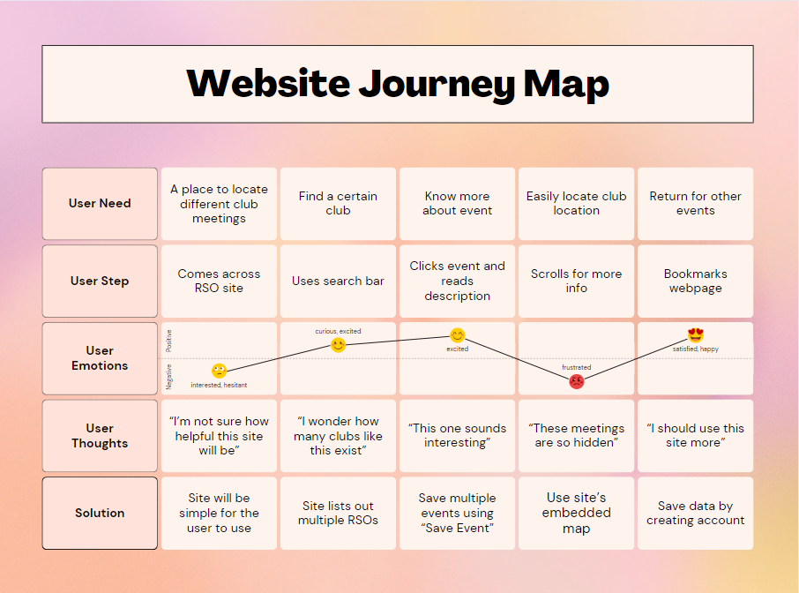

# Table of the user journey map. Shows how the solutions apply to the user’s needs.

# Bibliography

Balsamiq. (n.d.). Balsamiq. https://balsamiq.com/

Canva. (n.d.). Canva. https://www.canva.com/

Google. (n.d.). Google. https://www.google.com/

*Huskylink*. Explore - Registered Student Organizations UW (RSOs). (n.d.).

https://huskylink.washington.edu/

*UW Canvas*. Canvas Login. (n.d.). https://canvas.uw.edu/

# 

# Appendix

**References Images:**

1. **Canvas Calendar (wireframe inspiration):**

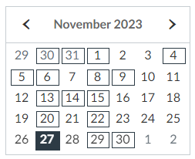

1. **Gmail icon (wireframe inspiration):**

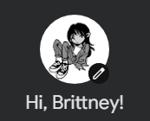

1. **Google Search Bar (wireframe inspiration):**

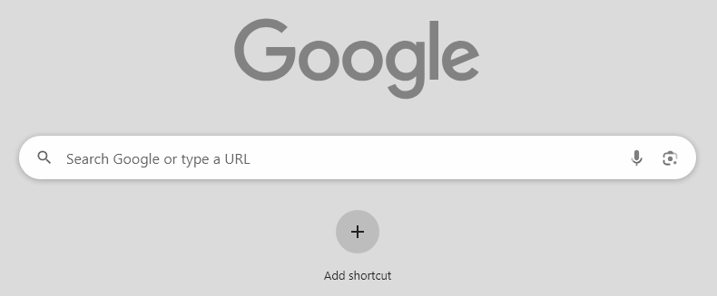

1. **Huskylink (RSOs) Home Page (wireframe inspiration):**

